Robo-Advisor

User Guide



# **Getting Started**

## **System Requirements and Dependencies**

* Python or Anaconda, and Python libraries as specified in requirements.txt
* A modern web browser. Recommended Google Chrome version 76 and above.
* GNU Make (https://www.gnu.org/software/make/) to utilise make commands in the repo.

## **Running Django server**

* Robo-advisor system can be started by running the front-end Django server. Start the front-end by typing the following in your Anaconda environment, in the **root directory** of the repo.

make front

* Alternatively, if 'make' is not installed, then you can type the following:

cd /d SystemCode/frontend/smartportfolioWeb/src

python manage.py runserver

* Then open Chrome and goto <http://127.0.0.1:8000/>

## **Creating a User Account / Logging in to a User Account**

* From the home page, click the “Sign Up” button at the top-right corner, and enter your email address, name and password, then click “Sign Up”

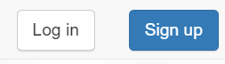

* Alternatively, if you want to see a preset account with existing portfolios, click the “Log in” button and use the following credentials:
  + Email address: [bob@hotmail.com](mailto:bob@hotmail.com)
  + Password: password
* You will be redirected to the Portfolio Management page

## **Add or Withdraw funds**

* In order to purchase any portfolios, you will need to have (virtual) funds in your account. You can do so by clicking the “Add/Withdraw funds” button

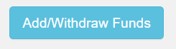

* Choose to either deposit or withdraw funds, enter the amount and click “Confirm”.

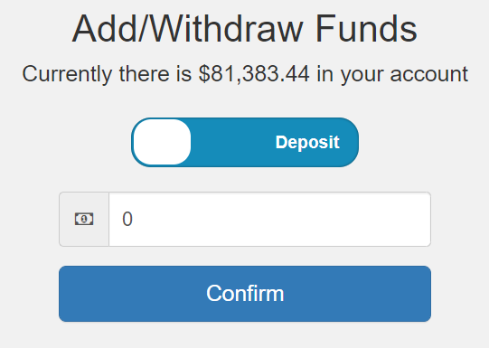

## **Buying a new Portfolio**

* Scroll down the page and you should see a list of **Available Portfolios**. You can sort the portfolios by name, risk, type, returns, etc
* Buy the portfolio that you want by clicking the “+” icon. It will be added to your list of available portfolios

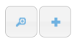

## **Selling an existing Portfolio**

* Scroll the page and you should see a list of **Current Portfolios**. You can see information such as its risk level, cumulative returns over 30 days and 1 year. In addition you can see the amount that you have invested in it, and its current value and earnings.
* Sell the portfolio that you want by clicking the “-” icon.



## **Viewing details of a Portfolio**

* You can click the magnifying glass icon in either the **Available Portfolio** section or **Current Portfolio** section, to see the details.



* Backtest results and key performance statistics will be shown. An example for “Sentimental All-Weather (Max Returns) is shown below

